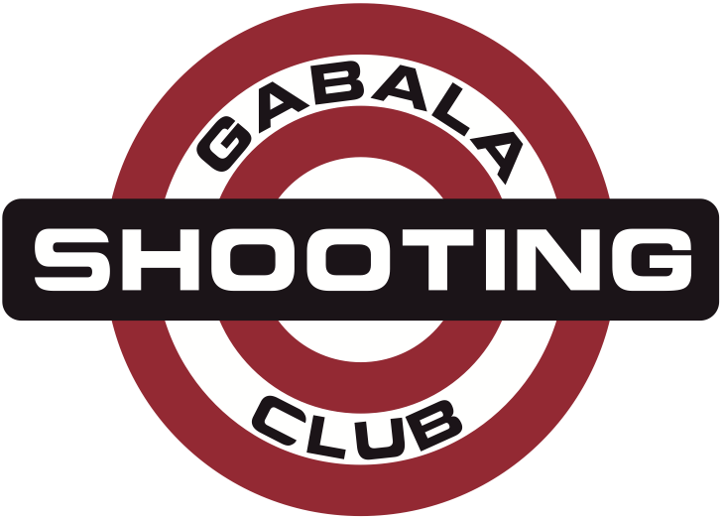
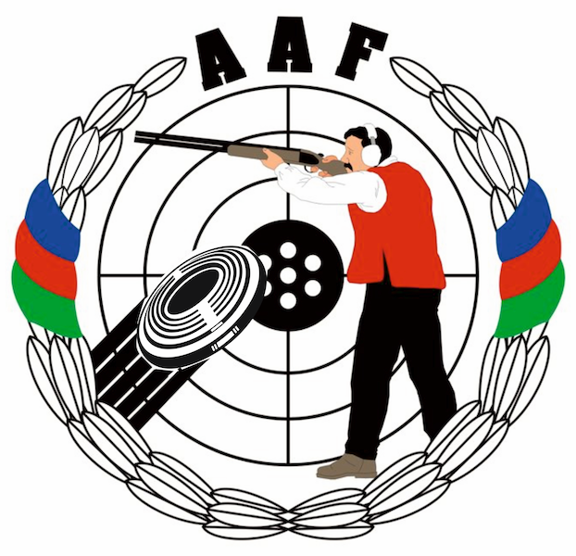
HEYDAR ALIYEV
INTERNATIONAL GRAND PRIX
Gabala, Azerbaijan
14 – 21 August 2014

FIREARM AND  AMMUNITION FORM |  |  |  |  | Please return by |  |  | to Organizing Committee
Please fill out and sign this form and email it together with copy of passport to the Organizing Committee.  Please use one form for each athlete. |  |  |  |  | 15 JUL 2014 |  |  | Lermontov str. 68  Baku, AZ1066, Azerbaijan  Phone: +994-50-5141515  Phone: +994-55-7537775  E-mail: info@gabala.eu
information
family name |  |  | first name
country |  |  | nationality
date of birth |  |  | place of birth
residential
address
passport number |  |  |  | place of issue |  |  |  |  | date of  expiry
firearms
model |  | manufacturer |  |  |  | serial number |  |  |  | gauge / caliber
ammunition
quantity |  | manufacturer |  |  |  | serial number |  |  |  | gauge / caliber
 |  | spare parts |  |  |  | manufacturer |  |  |  | quantity
barrels
stocks
travel information
arrival date |  | flight number |  |  |  | arrival time |  |  |  | carrier
departure date |  | flight number |  |  |  | departure time |  |  |  | carrier
Note:

Date |  | Signature of Athlete

